**Vector table Details of the MCU**

* Holds the table of addresses of pointers. Addresses of exception handlers (System exceptions + interrupts)
* 15 system exceptions + 240 interrupts

Found in the reference manual

when the processor turns into handler mode, whatever the exception is, it goes to the designated address in the memory to fetch the response to the exception that is stored there. The PC is set to the address described by the address of the exception handler

How the GPIO pin interrupts the processor?

* Check the reference manual=> check section 12.2 (external interrupt/event controller)
* Some peripherals deliver the interrupt to the NVIC over the EXTI controller/interface
* Some peripherals deliver their interrupt directly to the NVIC
* This is specific to the ST vendor and can vary for others

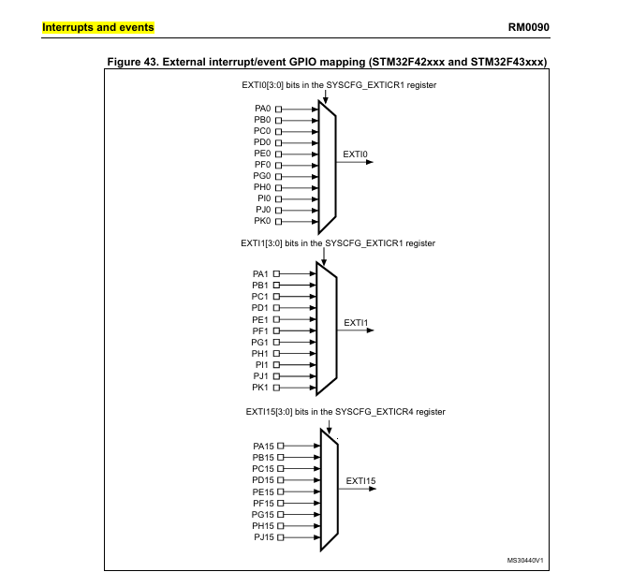

How does a button issue interrupt to the processor in STM32

1. The button is connected to the GPIO pin of the microcontroller
2. The GPIO pin should be configured to input mode
3. The link between a GPIO port and the relevant EXTI line should be established using the SYSCFG_EXTICRx register
4. Configure the trigger (falling/rising/both) for relevant EXTI line (done in the EXTI controller registers)
5. Implement the handler to service the interrupt

Volatile qualifier in C

* Used to indicate that a variable can be changed or modified by the compiler to optimize the code.
* Tells the compiler not to optimize the variable’s accesses, ensuring that every read and write operation to that variable happens exactly as specified in the code

GPIO (General purpose input and output)

* GPIO PORT is a collection of fixed number of I/O pins
* In STM32F407VG => 9 ports with 16 pins each = 144 GPIO pins
* Check section 8 of the reference manual for register details

* “input data register” will be updated for every 1 AHB clock cycle

Alternate Functionality of GPIO pins:

* GPIO pin can behave as an input, output, analog, interrupt, and as an alternative functionality mode
* When a GPIO is in alternative functionality mode it can be used for 16 different functionalities
* For further information go to “stm32f405rg_datasheet” document in section 4 and table 9 for details on alternate function mapping of the GPIO pins
* To configure the alternative function register => go to section 8.4.9-8.4.10 of the reference manual
* To enable disable the clock for GPIO pins => go to section 7.3.10 of the reference manual